**JOB RECRUITMENT & HIRING MANAGEMENT SYSTEM**

**NAME: KOLLI JAGAN MOHAN RAO**

**Phase 4 Report: Process Automation (Admin)**

* **Validation Rules**:
  + We created one key validation rule on the **Application__c** object. This rule prevents a user from saving a new application if the related **Candidate__c** record's **Resume__c** field is blank, ensuring that all applications have a resume before proceeding.

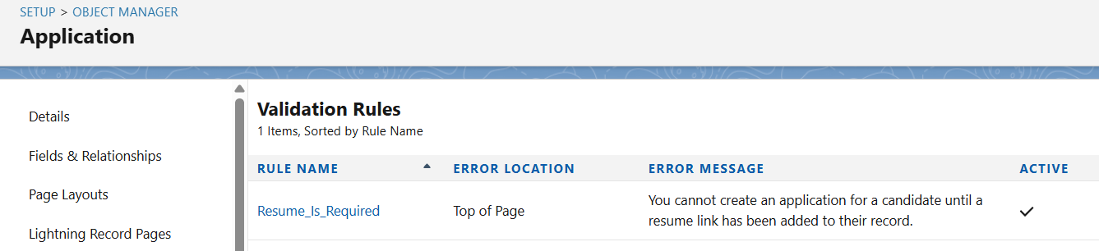

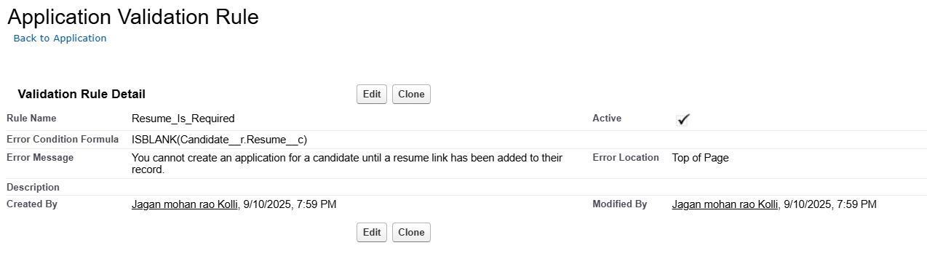

* **Approval Process**:
  + We implemented a formal, multi-step **Approval Process** on the **Job__c** object. The process automatically triggers when a new job is created with a status of "Pending Approval." It locks the record and assigns an approval request to the user listed in the **Hiring_Manager__c** field, ensuring proper sign-off before a job becomes active.
* **Flow Builder**:
  + We utilized a **Record-Triggered Flow**. This flow was configured to run whenever an **Application__c** record is updated to have a **Status__c** of "Interview." Upon triggering, the flow automatically creates a new, related **Interview__c** record, streamlining the transition between hiring stages. We did not build any Screen Flows, Scheduled Flows, or other Auto-launched Flows in this project.



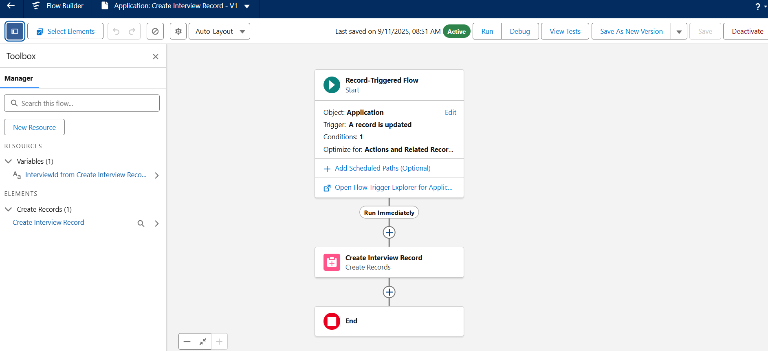

* **Email Alerts**:
  + We implemented email alerts using **Batch Apex** in Phase 5, rather than using the declarative Email Alert action. Our batch job was configured to send a follow-up email to candidates whose applications were still in progress.
* **Field Updates**:
  + We used **Field Update** actions as part of our **Approval Process**. When a Job__c record was approved, a field update changed its Status__c field to "Approved." Similarly, when it was rejected, a field update changed the status to "Rejected."



